Nights of Ramadan Tours –magical trips to Rahat
We are delighted to invite the public to unique night tours to Rahat during the celebrations of Ramadan.When the night becomes day and the streets are filled with the smells, colors, sounds and prayers... enjoy a memorable tour and an authentic homemade festive meal.
Trips take place on specific dates: Thursdays16 :/5/2019, 23/5/2019
Saturdays: 18/5/2019,20 /5/2019
Reception starting 16:00. Including Bedouin tea, coffee, tent hospitality and Henna hand paintings.
Guided tour, workshops, meal and performances between 16:30 and 21:30.
The tour will start on a bus ride, with professional explanations alongside spicy stories of a local Bedouin guide. We will get to know the "secrets Rahat", do a walking tour in the city center, visit the sweet shops, learn how to dance the "dabke" traditional Bedouin dance, learn how to prepare the special Ramadan treat “katayef”, meet an “IMAM”( religious leader) and learn about the Ramadan and the Islam. Finally we will enjoy a festive homely and authentic "iftaar" meal, after we will continue the tour to participate in festive street performances.
Details:
- Meeting point at 16:00 in the industrial zone Idan Hanegev, next to the parking lot of Soda stream company (waze directions: Soda Stream Rahat)
- Cost of the tour: 100 ₪per adult and 50₪ per child under 12.
- The cost includes the guided tour, workshops, performances, bus ride and dinner "iftaar".
- Vegetarian/vegan meals available
- Kosher meals available only for groups over 10 people, on the 16/5/2019, and the 23/5/2019
- Advanced registration and payment needed.
- The tour and guide is in Hebrew
- There is an option for tours for groups over 30 people during the entire Ramadan month (May-June) in Rahat. For details contact Naama Sapir at 052-7751565
For additional information email: bedo.tourism@gmail.com

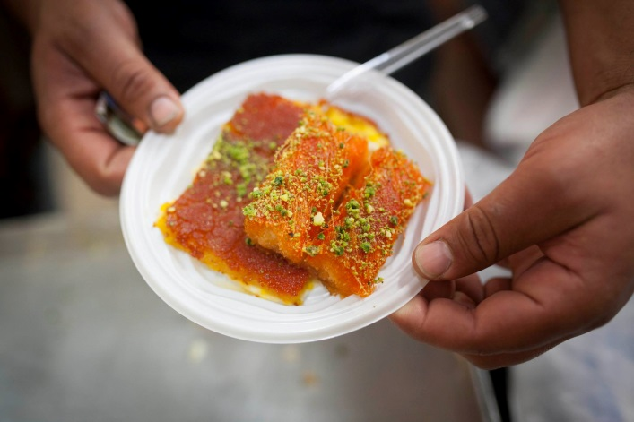 | 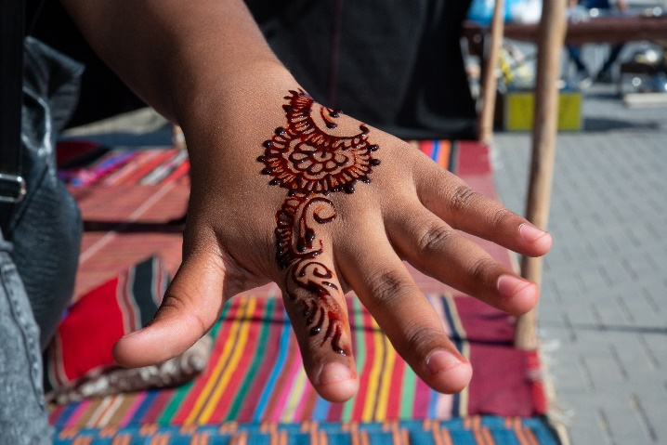
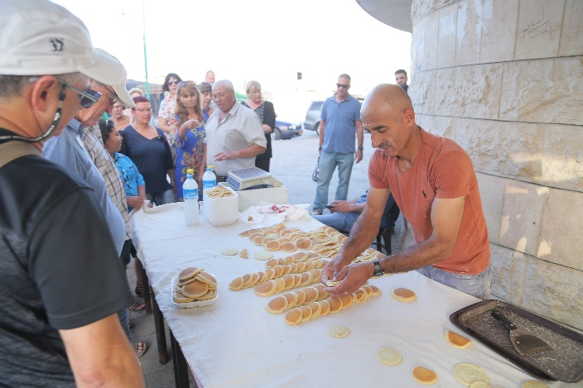 | 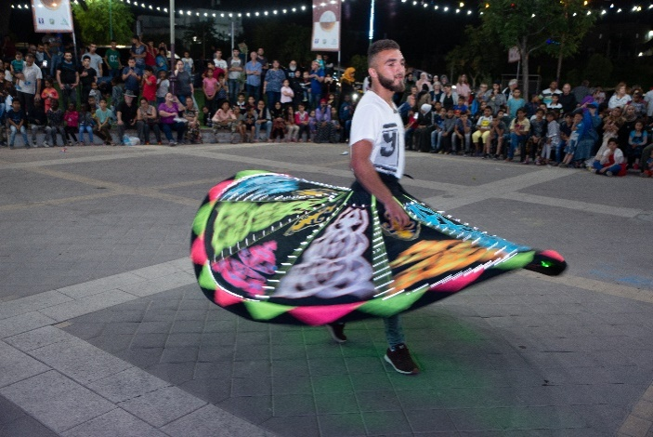
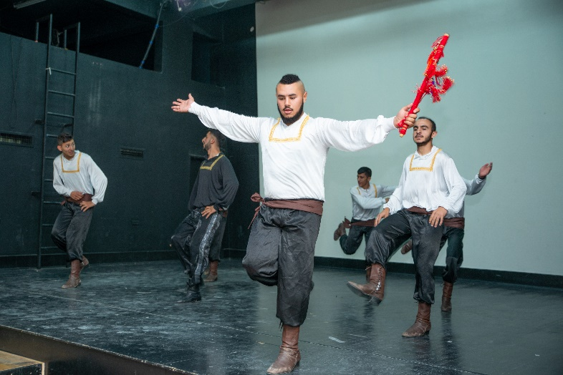 | 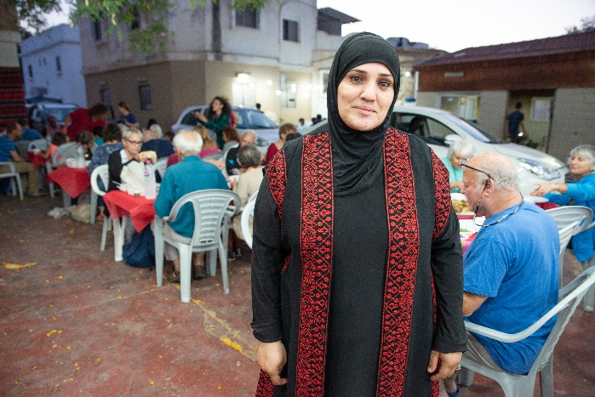
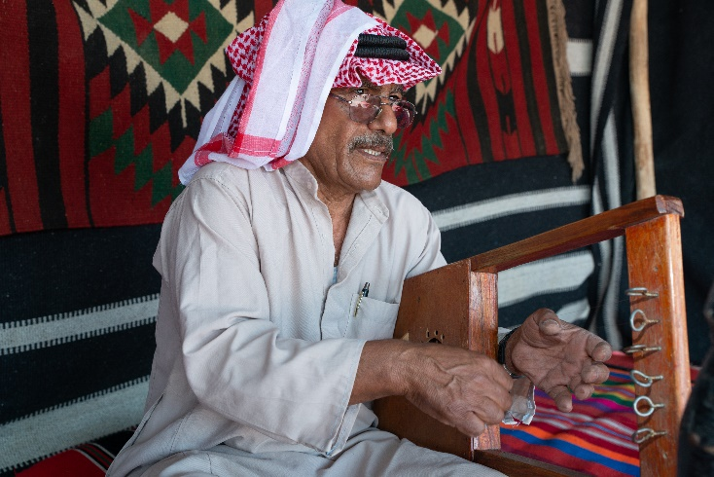 | 